Test Case: tc002_SPX_Dev5_Crear_Requisicion_Spot_Tipo_Cobro_Project
Step 1 - Enter username and password and click to button Enter: Credentials Entered
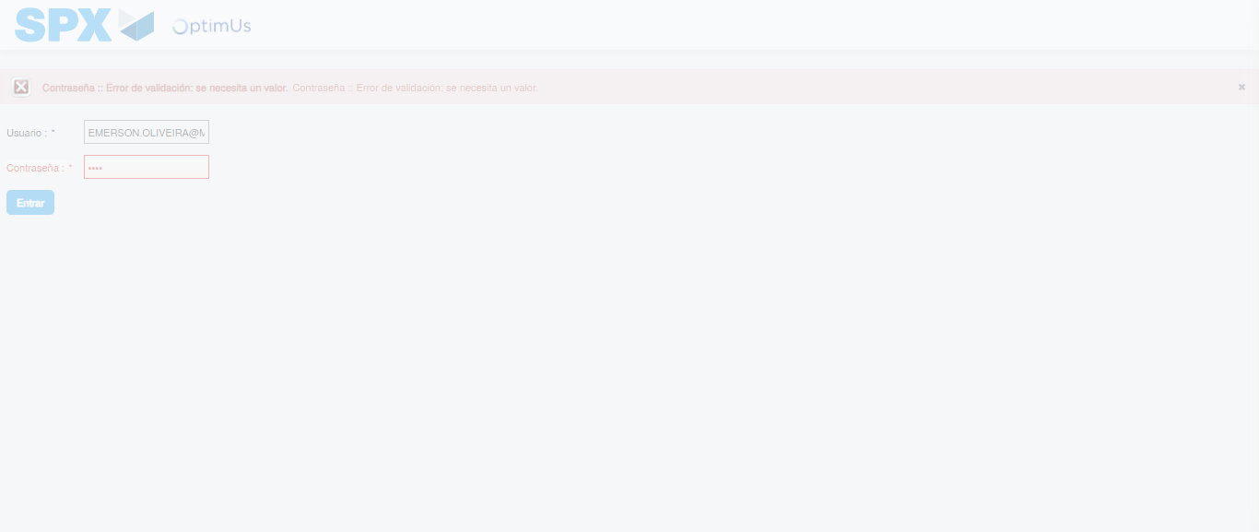Image file-name: QC_Testing-tc002_SPX_Dev5_Crear_Requisicion_Spot_Tipo_Cobro_Project-1784232325967

Step 2 - Select to UEN and Access to Spot Buy Requisitions : UEN Correctly selected and Correct access
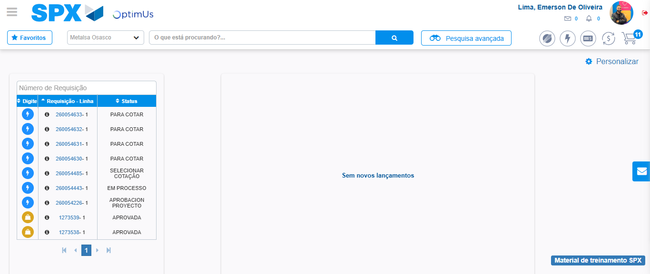Image file-name: QC_Testing-tc002_SPX_Dev5_Crear_Requisicion_Spot_Tipo_Cobro_Project-1784232351687

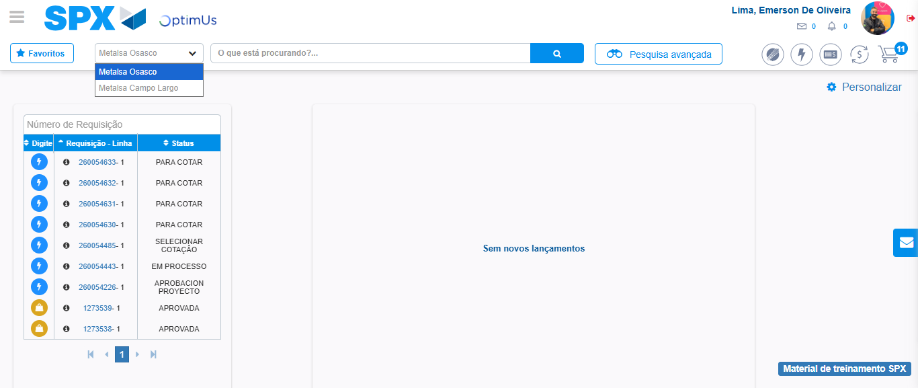Image file-name: QC_Testing-tc002_SPX_Dev5_Crear_Requisicion_Spot_Tipo_Cobro_Project-1784232354200

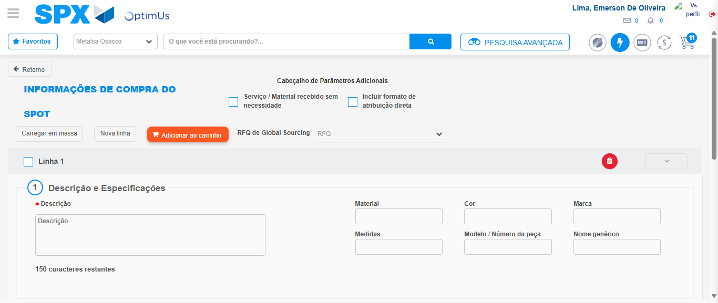Image file-name: QC_Testing-tc002_SPX_Dev5_Crear_Requisicion_Spot_Tipo_Cobro_Project-1784232375147

Step 3 - Data Capture Spot Buy Requisition: Data captured correctly
Image file-name: QC_Testing-tc002_SPX_Dev5_Crear_Requisicion_Spot_Tipo_Cobro_Project-1784232375400

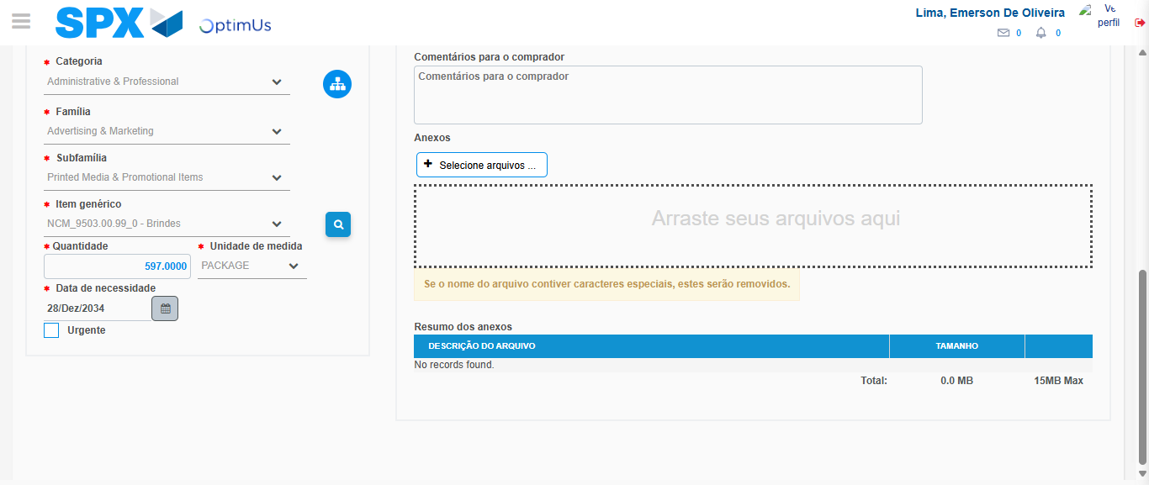Image file-name: QC_Testing-tc002_SPX_Dev5_Crear_Requisicion_Spot_Tipo_Cobro_Project-1784232387592

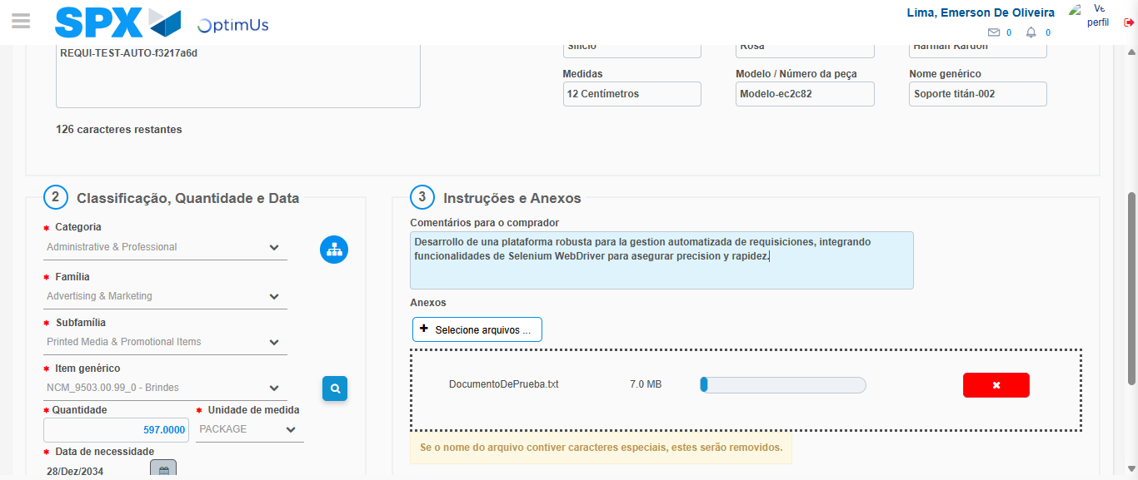Image file-name: QC_Testing-tc002_SPX_Dev5_Crear_Requisicion_Spot_Tipo_Cobro_Project-1784232388372

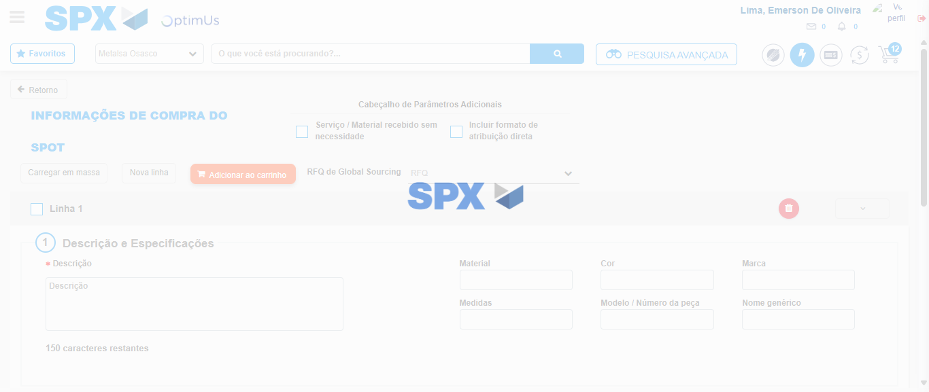Image file-name: QC_Testing-tc002_SPX_Dev5_Crear_Requisicion_Spot_Tipo_Cobro_Project-1784232392386

Step 7 - Return to Main Page SPX : Return to Main Page SPX
Image file-name: QC_Testing-tc002_SPX_Dev5_Crear_Requisicion_Spot_Tipo_Cobro_Project-1784232351687

Image file-name: QC_Testing-tc002_SPX_Dev5_Crear_Requisicion_Spot_Tipo_Cobro_Project-1784232354200

Image file-name: QC_Testing-tc002_SPX_Dev5_Crear_Requisicion_Spot_Tipo_Cobro_Project-1784232375147

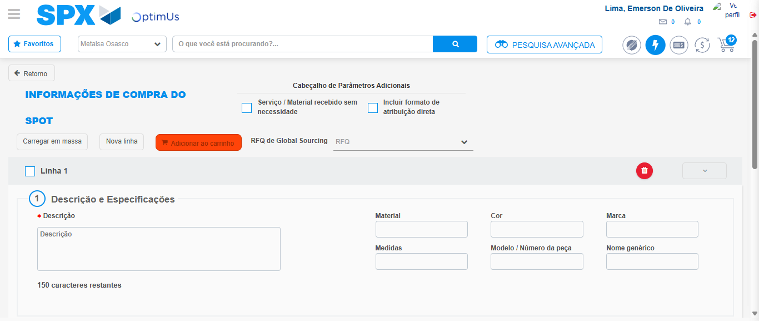Image file-name: QC_Testing-tc002_SPX_Dev5_Crear_Requisicion_Spot_Tipo_Cobro_Project-1784232394637

Image file-name: QC_Testing-tc002_SPX_Dev5_Crear_Requisicion_Spot_Tipo_Cobro_Project-1784232394794

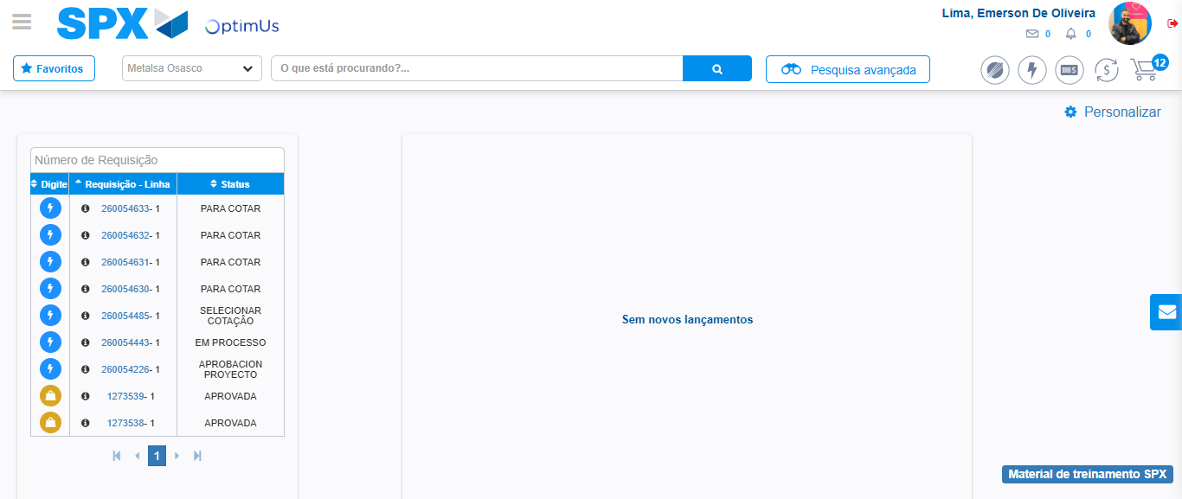Image file-name: QC_Testing-tc002_SPX_Dev5_Crear_Requisicion_Spot_Tipo_Cobro_Project-1784232415797

Step 8 - Log Out : Log Out SPX
Image file-name: QC_Testing-tc002_SPX_Dev5_Crear_Requisicion_Spot_Tipo_Cobro_Project-1784232415980

